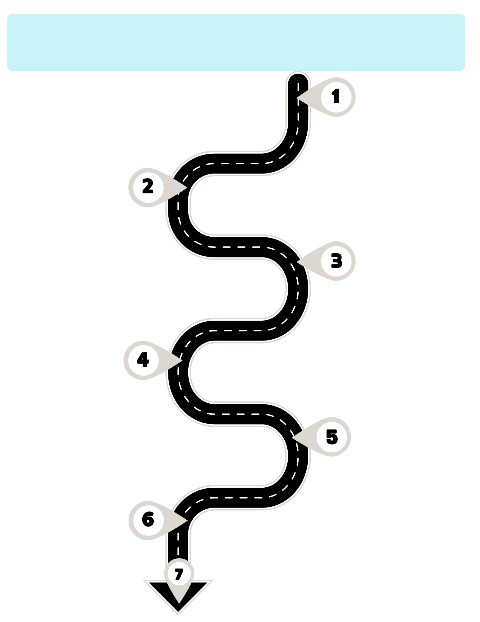
Executive Summary (see page 2)
Overall Plan Status: Select the current status of the overall plan.
Overall Progress: Provide a summary of your agency’s overall progress.
Key Achievements: Highlight significant accomplishments during this period.
Plan on Hold or Delayed: If the plan is on hold or delayed, provide
a detailed explanation.

Workforce Development FY 24/25 Sustainability Plan
Monitoring Report
Use this roadmap as a guide in completing report

Workforce Sustainability Plan Monitoring Overview (see page 2)
Change Leader: Enter the name of the person who is the change leader.
SMART Goal: Select improvement area category and enter each SMART goal, including the target completion, status, key actions completed and
next steps.
Milestone Status: For each provide a status update.
Attestation (see page 4): Complete the attestation and ensure that all sections are filled out accurately and comprehensively.
Challenges and Resolution Actions (see page 4)
Challenges: List any critical issues that have impacted completing goals.
Resolution Strategies: Describe the strategies used to resolve challenges.
Support Needed: Identify any support or resources needed.
What Did You Learn (see page 4)
Document any unexpected outcomes or lessons learned from implementing Year 1 activities.
Assessing Feedback (see page 4)
Describe how your agency is collecting and assessing staff feedback and engagement during the implementation process. This could include surveys, polls, or other communication strategies.
Retention Rate (see page 2)
Enter Retention Rate as of June 2024.
Enter Current Retention Rate as of the reporting period.
Indicate the Target Retention Rate and the achievement date.
Workforce Development FY 24/25 (Year 1) Sustainability Plan Monitoring Report
Choose One:

Report Date | agency name | prepared by (Full Name & Title) | E-MAIL/Phone Number
Click or tap to enter a date. | Click or tap here to enter text. | Click or tap here to enter text. | Click or tap here to enter text.

Executive Summary
Workforce Development Sustainability Plan Current Status: Choose an item.
Provide an overview of your agency’s overall progress and key achievements between Choose an item. towards implementation of FY 24/25 Sustainability Plan Strategies and Goals.
Overall Progress: Click or tap here to enter text.
Key Achievements: Click or tap here to enter text.
If plan is on hold or delayed provided a detailed explanation as to why. Must complete the Challenges and Resolutions (#4) section: Click or tap here to enter text.

REtention Rate
What was your original retention rate (June 2024) Click or tap here to enter text.
What is your agency’s current retention rate as of this reporting period? Click or tap here to enter text.
What is your agency’s target retention rate and achievement date? Click or tap here to enter text.
To be achieved by Click or tap to enter a date.

3. WORKFORCE SUSTAINABILITY PLAN MONITORING OVERVIEW (

Workforce development SUSTAINABILITY PLAN Change leader (CL): Click or tap here to enter text.

☐Original assigned CL ☐updated CL
FY 24/25 SMART GOALS | Milestone Implementation Status UPDATE
SMART GOAL 1
Improvement Area Category and Sub-Category:  Choose an item.  If Other, please specify: Click or tap here to enter text.  SMART Goal 1: ☐Original ☐Revised  Cut and paste from your original or enter revised SMART Goal 1  If SMART Goal 1 was revised, explain why:  Click or tap here to enter text.  SMART Goal 1 Target Completion Date:  Click or tap to enter a date.  Current Status: Choose an item.  Key actions completed: Click or tap here to enter text.  Will you achieve your measurable goal by Target Completion Date? ☐ Yes or ☐ No  Next Steps: Click or tap here to enter text. | Milestone 1.1: Cut and paste from your original or enter revised Milestone 1:1  ☐Original ☐Revised  Current Status: Choose an item.  Milestone 1.2: Cut and paste from your original or enter revised Milestone 1:2  ☐Original ☐Revised  Current Status: Choose an item.  Milestone 1.3: Cut and paste from your original or enter revised Milestone 1:3  ☐Original ☐Revised  Current Status: Choose an item.
NOTE: For goals and milestones reported as Delayed or On Hold, please use section 4 to list critical issues that have impacted timely progress.
SMART GOAL 2
Improvement Area Category and Sub-Category:  Choose an item.  If Other, please specify: Click or tap here to enter text.  SMART Goal 2: ☐Original ☐Revised  Cut and paste from your original or enter revised SMART Goal 2  If SMART Goal 2 was revised, explain why:  Click or tap here to enter text.  SMART Goal 2 Target Completion Date:  Click or tap to enter a date.  Current Status: Choose an item.  Key actions completed: Click or tap here to enter text.  Will you achieve your measurable goal by Target Completion Date? ☐ Yes or ☐ No  Next Steps: Click or tap here to enter text. | Milestone 2.1: Cut and paste from your original or enter revised Milestone 2:1  ☐Original ☐Revised  Current Status: Choose an item.  Milestone 2.2: Cut and paste from your original or enter revised Milestone 2:2  ☐Original ☐Revised  Current Status: Choose an item.  Milestone 2.3: Cut and paste from your original or enter revised Milestone 2:3  ☐Original ☐Revised  Current Status: Choose an item.
NOTE: For goals and milestones reported as Delayed or On Hold, please use section 4 to list critical issues that have impacted timely progress.
SMART GOAL 3
Improvement Area Category and Sub-Category:  Choose an item.  If Other, please specify: Click or tap here to enter text.  SMART Goal 3: ☐Original ☐Revised  Cut and paste from your original or enter revised SMART Goal 3  If SMART Goal 3 was revised, explain why:  Click or tap here to enter text.  SMART Goal 3 Target Completion Date:  Click or tap to enter a date.  Current Status: Choose an item.  Key actions completed: Click or tap here to enter text.  Will you achieve your measurable goal by Target Completion Date? ☐ Yes or ☐ No  Next Steps: Click or tap here to enter text. | Milestone 3.1: Cut and paste from your original or enter revised Milestone 3:1  ☐Original ☐Revised  Current Status: Choose an item.  Milestone 3.2: Cut and paste from your original or enter revised Milestone 3:2  ☐Original ☐Revised  Current Status: Choose an item.  Milestone 3.3: Cut and paste from your original or enter revised Milestone 3:3  ☐Original ☐Revised  Current Status: Choose an item.
NOTE: For goals and milestones reported as Delayed or On Hold, please use section 4 to list critical issues that have impacted timely progress.

Challenges AND RESOLUTION ACTIONS
List any challenges that impacted progress towards completing goals and milestones of your agency’s workforce development sustainability plan during the reporting period. Add extra rows if necessary.

Challenge |  | Associated GOAL |  | Resolution Strategies | Support needed
Click or tap here to enter text. |  | Choose an item. |  | Click or tap here to enter text. | Click or tap here to enter text.
Click or tap here to enter text. |  | Choose an item. |  | Click or tap here to enter text. | Click or tap here to enter text.
Click or tap here to enter text. |  | Choose an item. |  | Click or tap here to enter text. | Click or tap here to enter text.

Assessing Feedback
Describe how you are collecting and assessing staff feedback and engagement as you implement the changes: (prompt: surveys, qualitative or quantitative feedback, polls, communication strategies)

Click or tap here to enter text.

What did you learn? - Unexpected Outcomes or lessons learned
Explain any observations or lessons learned in implementing Year 1 activities:
Click or tap here to enter text.

attestation
By entering my name and title below and submitting this monitoring report, I confirm that the information reported is accurate and complete to the best of my knowledge.
Name: Click or tap here to enter text.
Title: Click or tap here to enter text.
Date: Click or tap to enter a date.

CIBHS USE ONLY
Draft Review/Feedback | Did agency submit the draft monitoring report to CIBHS for review prior to submitting to SAPC? Choose an item.  CIBHS Review Date: Click or tap to enter a date. | Review Feedback: Click or tap here to enter text.

FOR SAPC USE ONLY
Strategic and Network Development Division | Does this agency have a SAPC-approved Workforce Sustainability Plan? Choose an item.  Final Determination for Monitoring Report:  Choose an item.  Date: Click or tap to enter a date. | Comments: Click or tap here to enter text.
Finance Services Division | Approved: ☐ Click or tap here to enter text.  Date: Click or tap to enter a date.  Provider Tier Level: ☐Tier 1 ☐Tier 2 ☐Tier 3 | Comments: Click or tap here to enter text.

Appendix 1: Example

Workforce Development FY 24/25 (Year 1) Sustainability Plan Monitoring Report
Report 1-C [Due 11/30/24]

Report Date | agency name | prepared by (Full Name & Title) | E-MAIL/Phone Number
11/1/2024 | Flowers Agency | Violet Petal | vpetal@XXX.org

1. Executive Summary
Workforce Development Sustainability Plan Current Status: On Track
Provide an overview of your agency’s overall progress and key achievements between July 2024 to November 2024 towards implementation of FY 24/25 Sustainability Plan Strategies and Goals.
Overall Progress: From July 2024 to November 2024 our overall progress is on track. Our agency is seeing progress in achieving all SMART goals for FY 24/25. There were some challenges identified for our SMART Goal number 1 described below in challenges and resolutions.
Key Achievements: Some key achievements were, completing the wage analysis and staff participation in wellness committee meetings.
EXAMPLE
If plan is on hold or delayed provided a detailed explanation as to why. Must complete the Challenges and Resolutions (#4) section: Click or tap here to enter text.

2. REtention Rate
What your original retention rate (June 2024) 65%
What is your agency’s current retention rate as of this reporting period? 70%
What is your agency’s target retention rate and achievement date? 75%
To be achieved by 6/30/2025

3. SUSTAINABILITY PLAN MONITORING OVERVIEW

Workforce development SUSTAINABILITY PLAN Change leader (CL): Tulip Stem

☒Original assigned CL ☐updated CL
FY 24/25 SMART GOALS | Milestone Implementation Status UPDATE
SMART GOAL 1
Improvement Area Category and Sub-Category:  Salary Adjustment  If Other, please specify: Click or tap here to enter text.  SMART Goal 1: ☒Original ☐Revised  Increase wages for entry level counselors from $22.00 to $25.00 by January 1, 2025  If SMART Goal 1 was revised, explain why:  Click or tap here to enter text.  SMART Goal 1 Target Completion Date:  1/1/2025  Current Status: On Track  Key actions completed: A wage analysis was completed and revealed our agency is not consistent with similar positions in the LA area. Agency to proceed with developing clear objectives for the wage increase plan.  Will you achieve your measurable goal by Target Completion Date? ☒ Yes or ☐ No  Next Steps: Our next steps include: Assess the current financial resources which includes a profit and loss statement analysis for 2 years prior and our current projections. Present findings to the board for approval. Once approved, develop a draft of the wage increase plan, and share it with staff to obtain feedback. Then Agency will roll out the performance objectives and wage increase plan. | Milestone 1.1: Obtain Board Approval for the increase  ☒Original ☐Revised  Current Status: Complete  Milestone 1.2: Communicate clear objectives for the wage increase plan for clinical staff  ☒Original ☐Revised  Current Status: On Track  Milestone 1.3: Roll out the performance objectives and wage increase plan  EXAMPLE  ☒Original ☐Revised  Current Status: Delayed
NOTE: For goals and milestones reported as Delayed or On Hold, please use section 4 to list critical issues that have impacted timely progress.
SMART GOAL 2
Improvement Area Category and Sub-Category:  Staff Wellness - Wellness Committee/Activities  If Other, please specify: Click or tap here to enter text.  SMART Goal 2: ☒Original ☐Revised  Initiate a Staff Wellness Committee and Implement at least one Activity by March 31, 2025.  If SMART Goal 2 was revised, explain why:  Click or tap here to enter text.  SMART Goal 2 Target Completion Date:  3/31/2025  Current Status: On Track  Key actions completed: Agency created guidelines with our CEO and HR. Established the annual budget routed to supervisors for comment. A communication email was sent to staff to gauge interest and committee members were selected. First meeting schedule Nov. 1st. Developed a Sustainability and Continuous Improvement Plan. Finally, we are in the development stages of creating a staff survey to assess overall satisfaction and assess whether staff are happy and engaged.  Will you achieve your measurable goal by Target Completion Date? ☒ Yes or ☐ No  Next Steps: Our next steps include: Roll out wellness activity ideas to staff by December 1^{st.} Distribute staff survey in quarters 2 and 4 and have committee members vote on wellness activities. Target date for first wellness activity February 1, 2025. | Milestone 2.1: Establish Wellness Committee  ☒Original ☐Revised  Current Status: On Track  Milestone 2.2: Develop a Sustainability and Continuous Improvement Plan  ☒Original ☐Revised  Current Status: Complete  Milestone 2.3: Implement a minimum of one Wellness Activity  ☒Original ☐Revised  Current Status: On Track
NOTE: For goals and milestones reported as Delayed or On Hold, please use section 4 to list critical issues that have impacted timely progress.
SMART GOAL 3
Improvement Area Category and Sub-Category:  Professional Development - Leadership Skill Development  If Other, please specify: Click or tap here to enter text.  SMART Goal 3: ☒Original ☐Revised  Leadership will attend at least one Diversity and Inclusion workshops and create a diversity and inclusion practice guide to share with staff by January 1, 2025.  If SMART Goal 3 was revised, explain why:  Click or tap here to enter text.  SMART Goal 3 Target Completion Date:  1/1/2025  Current Status: On Track  Key actions completed: Leadership created a list of resources for DEI workshops, staff registered and complete 1 training and review takeaways at staff monthly meetings.  Will you achieve your measurable goal by Target Completion Date? ☒ Yes or ☐ No  Next Steps: Our next steps include: Tracker completion and create practice guide template and expectations. | Milestone 3.1: List of trainings distributed to all supervisors and managers.  ☒Original ☐Revised  Current Status: Complete  EXAMPLE  Milestone 3.2: Monitor and track attendance and key takeaways.  ☒Original ☐Revised  Current Status: On Track  Milestone 3.3: Create Diversity and Inclusion practice and share with staff on monthly basis  ☒Original ☐Revised  Current Status: On Track
NOTE: For goals and milestones reported as Delayed or On Hold, please use section 4 to list critical issues that have impacted timely progress.

4. Challenges AND RESOLUTION ACTIONS
List any challenges that impacted progress towards completing goals and milestones of your agency’s workforce development and sustainability plan during the reporting period. Add extra rows if necessary.

Challenge |  | Associated GOAL |  | Resolution Strategies | Support needed
Our agency encountered delays with Milestone 1.3, specifically the rollout of performance objectives and wage increases. This was due to a delay with Milestone 1.2, the draft of which is still pending approval. |  | Smart Goal 1 |  | Since we experienced some delays, the project manager assigned to Smart 1 goal has scheduled bi-weekly check-ins with the executive sponsor to ensure there is progress being made with smart goal 1 and to address any barriers to completion. | Will reach out to CIBHS for consultation.
Click or tap here to enter text. |  | Choose an item. |  | Click or tap here to enter text. | Click or tap here to enter text.
Click or tap here to enter text. |  | Choose an item. |  | Click or tap here to enter text. | Click or tap here to enter text.

5. Assessing Feedback
Describe how you are collecting and assessing staff feedback and engagement as you implement the changes: (prompt: surveys, qualitative or quantitative feedback, polls, communication strategies)

For SMART goal 1 & 3 our agency is using communication strategies to enlist staff feedback, and for SMART goal 2 we’re implementing a staff survey to assess overall satisfaction.

6. What did you learn? - Unexpected Outcomes or lessons learned
Explain any observations or lessons learned in implementing Year 1 activities:
For SMART Goal 1 we learned through our wage assessment analysis that our agency needs to increase wages to remain competitive within the network. We underestimated the time it takes to create performance plans for future increases that are fair and equitable. For SMART 2 goal, an unexpected outcome was staff excitement in creating a wellness committee.
EXAMPLE

7. attestation
By entering my name and title below and submitting this monitoring report, I confirm that the information reported is accurate and complete to the best of my knowledge.
Name: Violet Petal
Title: CEO/Executive Sponsor
Date: 11/1/2024

CIBHS USE ONLY
Draft Review/Feedback | Did agency submit the draft monitoring report to CIBHS for review prior to submitting to SAPC? Choose an item.  CIBHS Review Date: Click or tap to enter a date. | Review Feedback: Click or tap here to enter text.

FOR SAPC USE ONLY
Strategic and Network Development Division | Does this agency have a SAPC-approved Sustainability Plan? Choose an item.  Final Determination for Monitoring Report:  Choose an item.  Date: Click or tap to enter a date. | Comments: Click or tap here to enter text.
Finance Services Division | Approved: ☐ Click or tap here to enter text.  Date: Click or tap to enter a date.  Provider Tier Level: ☐Tier 1 ☐Tier 2 ☐Tier 3 | Comments: Click or tap here to enter text.

