Last updated by __________________________________ On _____________________________
- The Emergency Action Plan is meant to identify the types of emergencies and/or health hazards that may occur at the facility.
- It shall include a diagram of the entire facility.
- It shall include a list of emergency telephone numbers.
- It shall include the available methods of communication used between responders, emergency services, and bathers.
- It shall include record keeping (methods and reporting procedures).
- It shall include requirements for staff to train on the plan and practice for emergencies
- It shall be updated as often as necessary due to staffing changes or changes in roles.

FACILITY DIAGRAM
Provide a diagram of the entire facility. Indicate emergency exits, locations of safety equipment, and other pertinent information.

EMERGENCY NUMBERS
Below is a list of key contacts in the event of an emergency. This list of emergency numbers shall also be posted at the following locations at the facility: __________________________________

KEY CONTACTS | Number
Ambulance /Paramedics/Fire | 911
Poison Control
Local Police or Sheriff
Facility Director/Management
Supervising Lifeguard
Facility Maintenance

COMMUNICATION PLAN
In the event of an emergency, the following individuals are responsible for communicating the Department of Public Health, the media, and other agencies:
Role | Lead | Alternate

EMERGENCY PROCEDURES
Emergencies procedures for this facility provide the following information:
- Responders –Identification of each anticipated responder and their tasks to handle the emergency. (What is role of first/primary responder? Who will provide support? How is the plan adjusted for reduced staffing levels?)
- Location of appropriate safety equipment – List of equipment needed, its location and accessibility, and names of individuals trained to use it. Information of replacement or restocking is also included.
- Actions – The actions taken by the facility and responsible persons when there is a drowning, chemical spill, fire, earthquake, fight, etc.
- Communication – List of who needs to be contacted, who will do this, what are they to report, and method (equipment) to do so.
- Evacuations – Steps for evacuations and situations requiring evacuation.
- Pool closure – Situations leading to temporary closure of the public pools and steps taken to do so.
- Return to normal operations – List of actions needed to return to normal operations, including reopening of the pools.
- Updating the plans – Evaluation of the effectiveness of the plans and persons tasked with making changes to the plan, including new training.

SAMPLE PLAN TEMPLATE
EMERGENCY SITUATION:
Responders
Safety Equipment
Actions
Communication
Evacuation
Pool Closure
Return to Normal Operations
Updating Plan

Reporting/Record Keeping
The facility tests the disinfectant residual, pH and water temperature (heated pools) a minimum of once per day. All water test results, equipment readings, calibrations, and corrective action taken are recorded on a written daily log.
Additionally, following any emergency, the facility will record on an Emergency Report the number of bathers, number of lifeguards on duty, weather conditions, water clarity, water quality, and any reported rescues, injuries, and illnesses. Types of emergencies to be reported by site personnel are:
• Facility Emergency
• Weather Emergency
• Fire and Chemical Emergency
• Medical Emergency
• Drowning Emergency
• Other (specify)___________________________________

The incident may be documented and maintained on a paper or electronic report. The attached sample report can be utilized for each incident or a similar form that captures the same information.

Records are stored at ________________ and are maintained for at least two years.

Training/practice drills
The facility shall provide training on this plan and schedule practice drills as follows:

SAMPLE DAILY OPERATIONAL RECORD
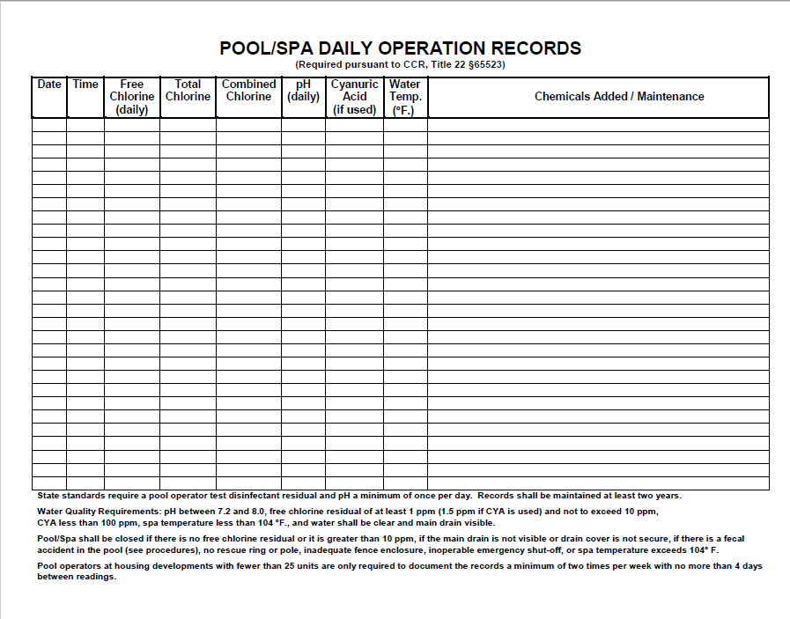

SAMPLE EMERGENCY REPORT
Facility Name: |  | Date of Incident:
Facility Address: |  | Time of Incident:
Report Completed By: |  | Contact Phone #:
Description of Emergency Incident:

Possible cause of the incident:
Actions are taken by responders:
Number of Bathers: | Water Clarity:
Number of Lifeguards on Duty: | Weather Conditions:
Water Quality: pH _____ Disinfectant (i.e.- free chlorine) _____ ppm
Pool Closed? No Yes Time Pool(s) closed: Date and time reopened:
Notifications made to:
(Include date/time, person contacted, number, and if any rescues/injuries/illnesses were reported)
Emergency Action Plan followed? Yes No
Lessons learned or improvements needed:
Other comments:
Use additional sheets if needed. Attach any reports/notices received from first responders/agencies.

